[](https://vk.com/photo-57880788_456240438)

[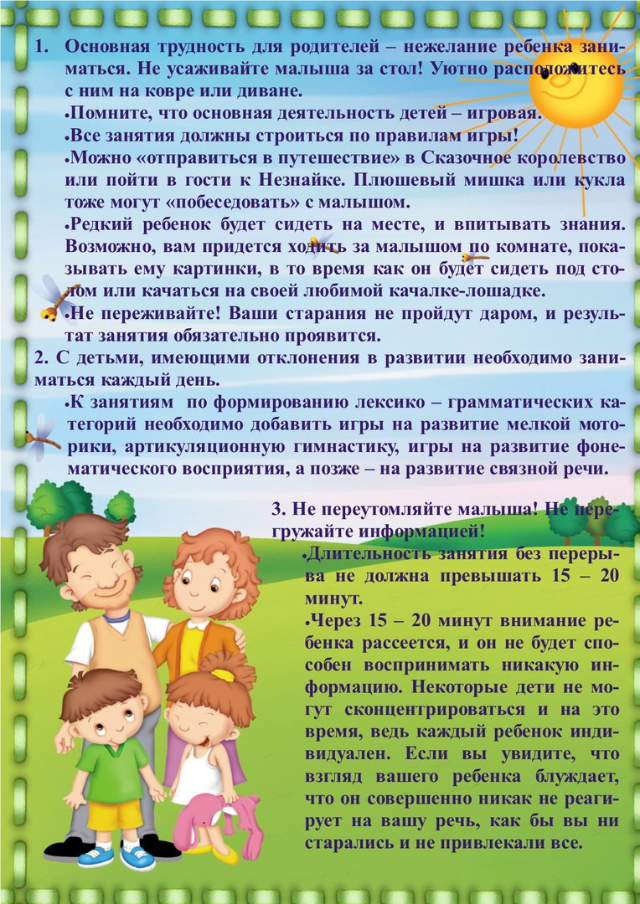](https://vk.com/photo-57880788_456240439)

[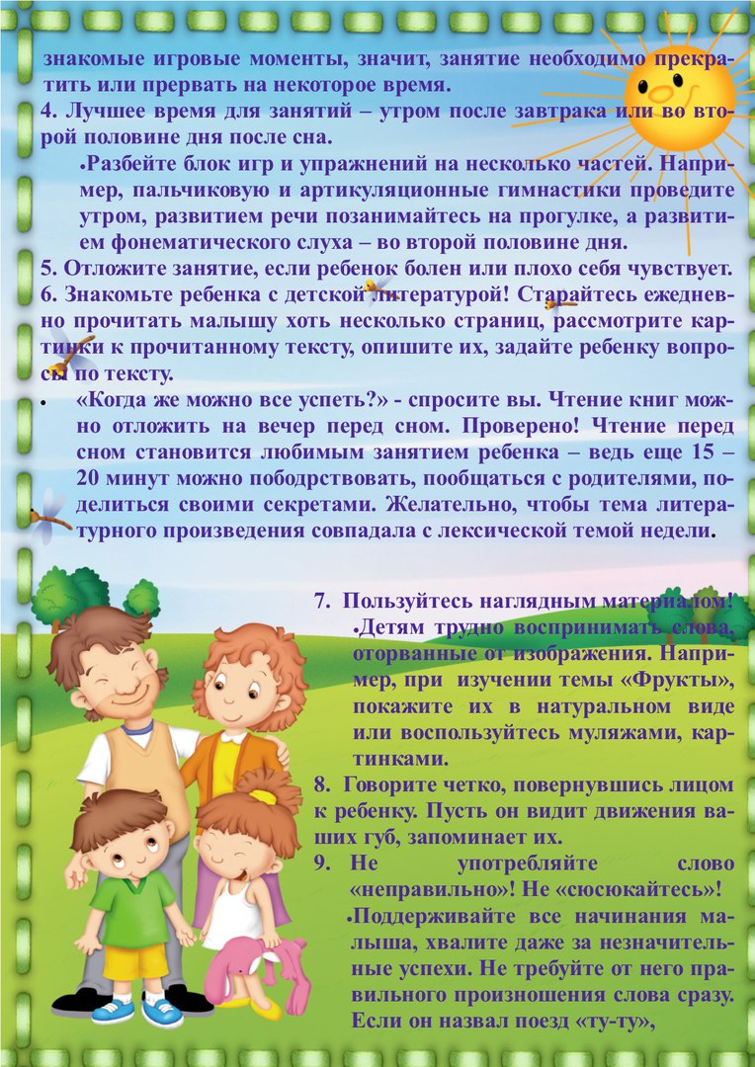](https://vk.com/photo-57880788_456240440)

[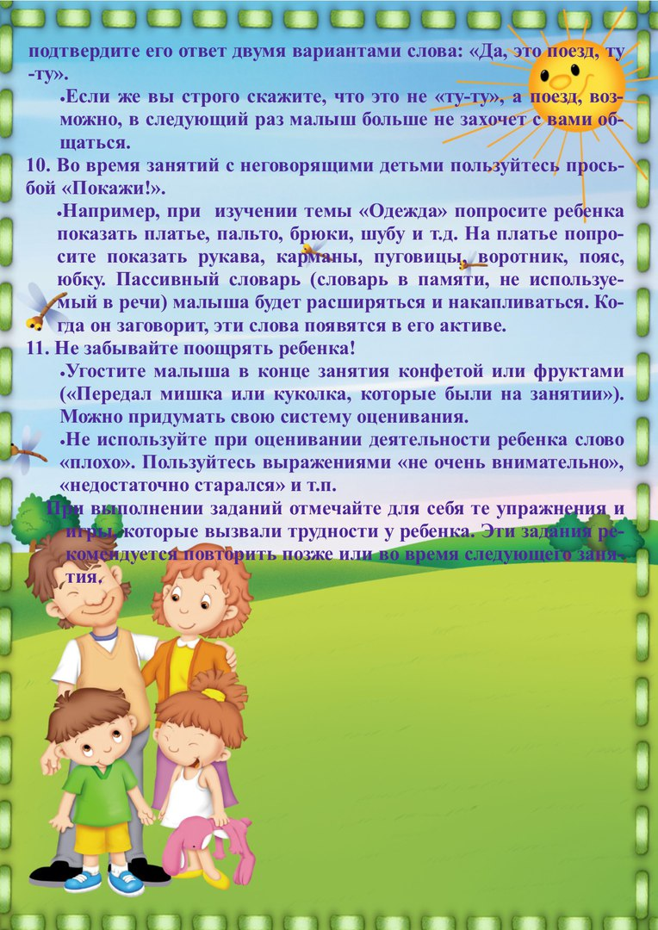](https://vk.com/photo-57880788_456240441)